21BDS0340

Abhinav Dinesh Srivatsa

Compiler Design Lab

Assignment – III

**Question 1**

Aim:

Write a lex program to find out total number of vowels and consonants from a given string

Program:

%{

#include <stdio.h>

int vowelCount = 0;

int consonantCount = 0;

%}

**%%**

[aAeEiIoOuU] { vowelCount++; }

[a-zA-Z] { consonantCount++; }

. ;

**%%**

int main() {

yy_scan_string("Hello, World!");

yylex();

printf("Vowel count: %d\n", vowelCount);

printf("Consonant count: %d\n", consonantCount);

return 0;

}

Output:

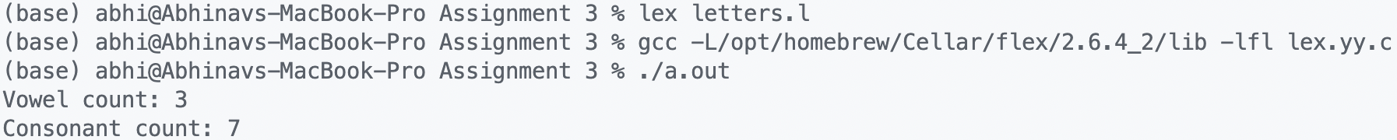

**Question 2**

Aim:

To convert an abstract syntax tree to machine code

Code:

#include <iostream>

using namespace std;

int num = 0;

void threeAddress(string input)

{

// checking brackets

string copy = input;

reverse(copy.begin(), copy.end());

for (int x = 0; x < input.length(); x++)

if (input[x] == '(')

for (int y = 0; y < input.length(); y++)

if (copy[y] == ')')

{

threeAddress(input.substr(x + 1, input.length() - y - 1 - x - 1));

input = input.substr(0, x) + "t" + to_string(num++) + input.substr(input.length() - y);

copy = input;

reverse(copy.begin(), copy.end());

break;

}

// checking priority

int op_index = 0;

char op = '+';

int op_count = 0;

for (int x = 0; x < input.length(); x++)

{

if (input[x] == '+' || input[x] == '-' || input[x] == '*' || input[x] == '/')

op_count++;

if (input[x] == '/')

{

op_index = x;

op = '/';

}

else if (input[x] == '*' && op != '/')

{

op_index = x;

op = '*';

}

else if (input[x] == '-' && op != '/' && op != '*')

{

op_index = x;

op = '-';

}

else if (input[x] == '+' && op != '/' && op != '*' && op != '-')

{

op_index = x;

op = '+';

}

}

if (op_count > 1)

{

int t1_n = 0, t2_n = 0;

for (int x = op_index - 1; x >= 0; x--)

{

if (input[x] == '+' || input[x] == '-' || input[x] == '*' || input[x] == '/' || input[x] == '=')

break;

t1_n = x;

}

for (int x = op_index + 1; x < input.length(); x++)

{

if (input[x] == '+' || input[x] == '-' || input[x] == '*' || input[x] == '/' || input[x] == '=')

break;

t2_n = x;

}

string temp = input.substr(t1_n, t2_n - t1_n + 1);

threeAddress(input.substr(t1_n, t2_n - t1_n + 1));

input = input.substr(0, t1_n) + "t" + to_string(num++) + input.substr(t2_n + 1);

threeAddress(input);

}

else

{

string token1 = "", token2 = "";

for (int x = 0; x < input.length(); x++)

if (input[x] == '+' || input[x] == '-' || input[x] == '*' || input[x] == '/' || input[x] == '=')

{

token1 = token2;

token2 = "";

op = input[x];

}

else

token2 += input[x];

std::cout << "t" << num << " = " << token1 << " " << op << " " << token2 << "\n";

}

}

int main()

{

string input;

cin >> input;

threeAddress(input);

}

Output:

